Student’s Name
Instructor’s Name
Course
Date
HYPOCRISY
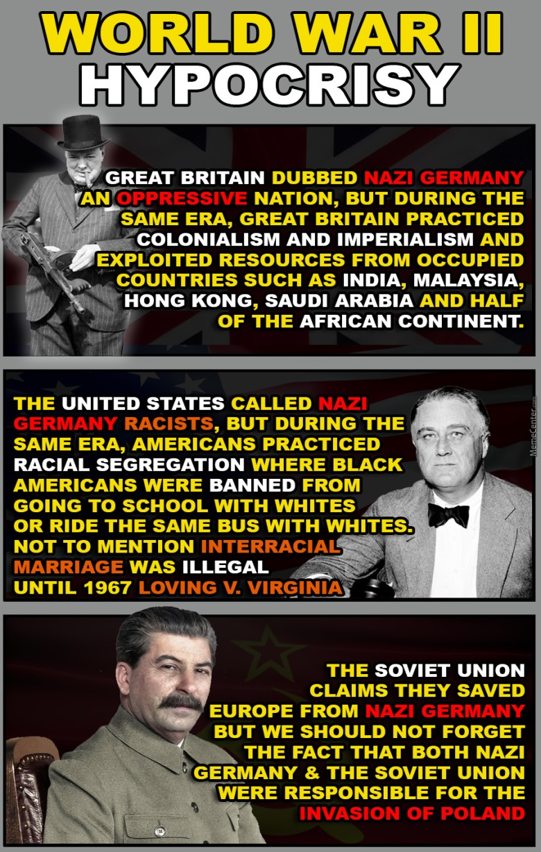
The process of engaging in the same behavior that one criticizes another is known as hypocrisy. Hypocrisy is also the failure to confirm one action according to moral standards or beliefs to which one claims to have. Political hypocrisy is one of the most expressed hypocrisy in our society, where politicians fool the public to get the political benefit. In America, social media has been used to express hypocrisy in politics in the form of memes. In my paper, I discuss how hypocrisy is expressed in World War II in the form of a meme.
Great Britain shows hypocrisy when they nickname Nazi Germany an oppressive nation. This because their behavior does not conform to their words; Great Britain is seen to colonialize countries like Malaysia, India, and many others. Where oppression is their technique to dominate and grab their resources, oppression is seen in the Nazi government. Propagandas were spread to brainwash the citizens. Any media that did not cooperate in the spread of Nazi ideas was suppressed. Religion was seen as a threat to the Nazi's agendas. The freedom of worship was taken from the people by the Nazi government. The Jewish were mistreated and persecuted by the Nazi government. Although oppression was seen in Germany, Great Britain did not qualify to criticize the actions of the Nazis. It was because the British abused the human rights of Indians and other countries that they colonized. British expressed the ambitions of maintaining the worldwide empire but still tried to stop Germany from acquiring its realm (Finnemore, Martha, pg 58, 2009). These acts show how Britain was acting opposite to moral beliefs.
They saw racism in the dictatorial government of Germany. The structure of Hitler’s state was around racial ideologies. Americans express hypocrisy when they condemn the Germans for their racial discrimination and neglecting to look at how racism had taken roots in their own country. Germany had passed policies that racially discriminated Jewish and any other group of people regarded as "undesirable." The Nazis believed that no non-Germany should have citizenship rights and only the Germans can be a citizen. According to the Nazis' racial philosophy, some races are subhuman and believed that people with social problems and disabilities are genetically less human. They need to be eliminated from the human pool's gene. Nazis expressed immoral actions which the United States criticized. The United States' critics were an expression of hypocrisy since racial discrimination was seen mainly in America. The blacks were seen as an outcast and given separate education housing and other services. It was believed that the white and the black people were not capable of living together. The white people viewed the blacks as an inferior race. They passed policy laws to make racial segregation official in America. Severe effects undermined the black people who closed the neighboring to the residence of the white. Intermarriages between the two races were illegal. Blacks could only marry the blacks and vice versa. The intermarriage situation was changed by the Supreme Court's policies and allowed marriage across the race. The incidence expressed by the meme above shows how American was hypocritical to the Germanys perspective of racial discrimination (Roda et al., Pg 27, 2016).
The hypocrisy is seen in the Soviet Union when they launched an attack to fight against the Nazis, and they were collaborators in the inversion of Poland. In the goals of political expansion of German, from the establishment of the Nazi movement, the Soviet Union was expressed as an enemy in which attacks were inevitable. The Nazi propagandas constantly attacked the Soviet Union, which created a motive for future episodes. Regardless of the conflict between the two parties Germany adopted a temporary move to cooperate with the Soviet Union. The reason for cooperation was to join efforts so that Germany can conquer Poland while Hitler secures his eastern flank. Germany and the Soviet Union signed treaties for collaboration and to ensure peaceful coexistence among them. The two parties went into business together where the soviet would acquire manufactured goods in return for raw materials to Germany. The unification of the Soviet and Germany assured Germany to attack Poland without the fear of the Soviet Union. The attack on Poland triggered world war II since France and Britain had agreed to protect Poland's borders. Later on, Hitler broke the agreement with the Soviet Union, and they attacked the Soviets. The first wave of attack was a surprise to the Soviets; hence many soviet soldiers were forced to surrender. Later in December, the Soviets were able to launch an attack on Germans which pushed the Germans out of Moscow. After a long period of war, the Germans were defeated and surrendered unconditionally. So the claims of the Soviet Union to save Europe were hypothetical since their unification with the Nazis was one of the significant contributions of World War II.
In summary, the media uses memes to communicate vital information to society. In our instance, the meme was used to express how hypocrisy has spread even in society's higher short position. Countries and politicians are hiding behind hypocrisy to fool the people on how they are helping them. Many countries criticized the Nazi dictatorial leadership and failed to self-reflect on how they're treating their citizens. Media is playing an essential role in addressing contemporary issues in society using various forms.

Work Cited
Finnemore, Martha. "Legitimacy, hypocrisy, and the social structure of unipolarity." World Pol. 61 (2009): 58.
Roda, Allison, and Amy Stuart Wells. "School choice policies and racial segregation: Where white parents’ good intentions, anxiety, and privilege collide." American Journal of Education 119, no. 2 (2016): 261-293.

Finnemore, Martha. "Legitimacy, hypocrisy, and the social structure of unipolarity." World Pol. 61 (2009): 58.
Finnemore, Martha. "Legitimacy, hypocrisy, and the social structure of unipolarity."
Roda, Allison, and Amy Stuart Wells. "School choice policies and racial segregation: Where white parents’ good intentions, anxiety, and privilege collide."
Roda, Allison, and Amy Stuart Wells. "School choice policies and racial segregation: Where white parents’ good intentions, anxiety, and privilege collide."

